**BiteBalance**

**Group Members Details:**

Rhythm Juneja – 16010122077

Rahil Kothari – 16010122088

Romil Lodaya – 16010122096

Website – [BiteBalance](https://bitebalance.vercel.app/)

Figma Design - [Figma _BiteBalance](https://www.figma.com/design/IRA82EhYEpqcCa1L4kzLiF/ByteBalance?node-id=27-278&node-type=frame)

**Objective:**

The primary objective of **BiteBalance** is to create an intelligent, user-friendly platform that simplifies the process of tracking meals and maintaining a healthy diet. The application aims to:

1. **Automate Meal Recognition**: Use AI to identify ingredients and nutritional content from images of food, reducing manual input for users.
2. **Calorie and Macros Tracking**: Provide accurate and detailed breakdowns of calories, proteins, fats, carbohydrates, and other essential nutrients based on recognized meals.
3. **Personalized Meal Recommendations**: Generate custom recipes and meal suggestions tailored to users' dietary preferences, restrictions, and health goals.
4. **Visualize Nutrition Data**: Offer clear and concise insights into daily, weekly, or monthly nutrient intake to help users make informed dietary choices.

**Work distribution (functionality wise):**

**Person 1: Rahil Kothari**

**Backend Development:**

* Set up the Node.js server and created API endpoints for meal recognition, ingredient identification, and calorie tracking.
* Managed MongoDB database schema design, including creating the User model and implementing logic for storing and updating user nutritional data.
* Handled the connection to MongoDB Atlas and ensured secure integration via environment variables using dotenv.

**AI Integration:**

* Developed prompt engineering for Google Gemini AI to refine meal recognition accuracy and improve recipe generation outputs.
* Managed AI service communication for handling image data, nutritional information, and generating tailored meal plans.
* Integrated Google Gemini AI for generating content (meal recognition, ingredient extraction, and recipe generation).

**Deployment & Configuration:**

* Managed project configuration, environment setup, and backend deployment to cloud services.
* Implemented error handling and API documentation for seamless communication between frontend and backend.

**Person 2: Romil Lodaya**

**Frontend Development:**

* Built the React.js frontend, creating dynamic pages for meal recognition, calorie tracking, and the user dashboard.
* Integrated Material UI (MUI) to design a responsive, user-friendly interface with a modern look.
* Implemented functionality allowing users to upload food images, view real-time calorie and macro breakdowns, and generate recipe suggestions.
* Worked on integrating Firebase Authentication for secure login, signup, and user management.

**AI Response Handling:**

* Collaborated with Person 1 on handling and optimizing Google Gemini AI responses for ingredient recognition and recipe generation.
* Implemented data parsing logic for cleaning and formatting JSON responses from the AI.

**State Management:**

* Managed state across the application using React Hooks and ensured seamless data flow between components.
* Implemented real-time updates to display users’ nutritional data and suggestions.

**Person 3: Rhythm Juneja**

**Frontend & UI/UX Design:**

* Assisted in building the React.js frontend with dynamic pages for meal recognition and user statistics.
* Collaborated with Person 2 to ensure a seamless user experience and modern design principles using Material UI (MUI).
* Led the Figma design phase, creating wireframes and mockups for the project’s UI/UX to ensure visual consistency.

**Testing & Debugging:**

* Conducted unit testing and integration testing for both frontend and backend to ensure all features worked as expected.
* Performed user acceptance testing (UAT) to validate that the user interface is intuitive and responsive across devices.
* Assisted in debugging issues related to image uploads, large JSON responses, and meal recognition accuracy.

**Database:**

**Type:**

The project uses **MongoDB Atlas**, a cloud-based NoSQL database, allowing flexible and scalable storage of user data such as daily calorie intake, macro breakdowns, and user preferences.

**Structure:**

**User Collection**:

* + uid (String): Unique identifier for each user, linked to Firebase authentication.
  + totalCalories (Number): Total calories consumed on a given day.
  + totalProtein (Number): Total protein consumed.
  + totalSugars (Number): Total sugar intake.
  + totalCarbs (Number): Total carbohydrates consumed.
  + totalFats (Number): Total fat intake.
  + totalSodium (Number): Total sodium intake.
  + date (Date): Date of the entry (set to the start of the day).

Each document represents a daily nutritional record for a user, making it easy to track daily stats.

**Relevant Configurations:**

* Connection to MongoDB Atlas is handled via **Mongoose**, with environment variables (via dotenv) securely managing the MongoDB URI and API keys.
* Mongoose handles schema validation and data modeling for easy retrieval and manipulation of user nutritional data.

**Screenshot:**

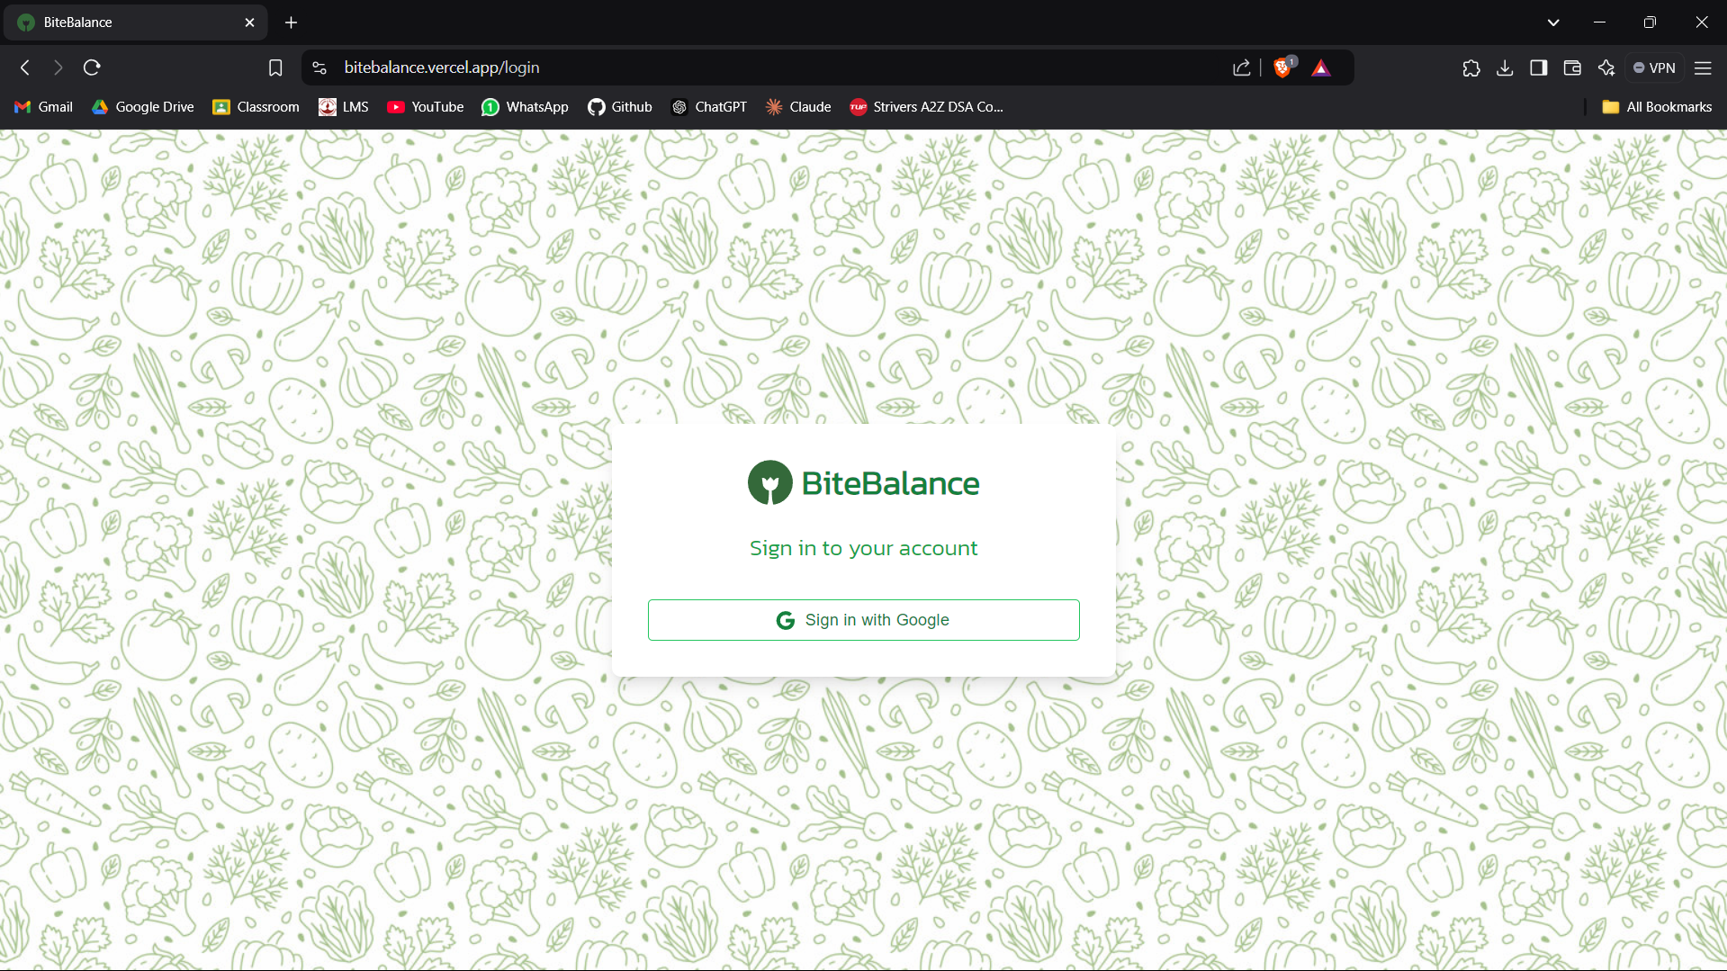

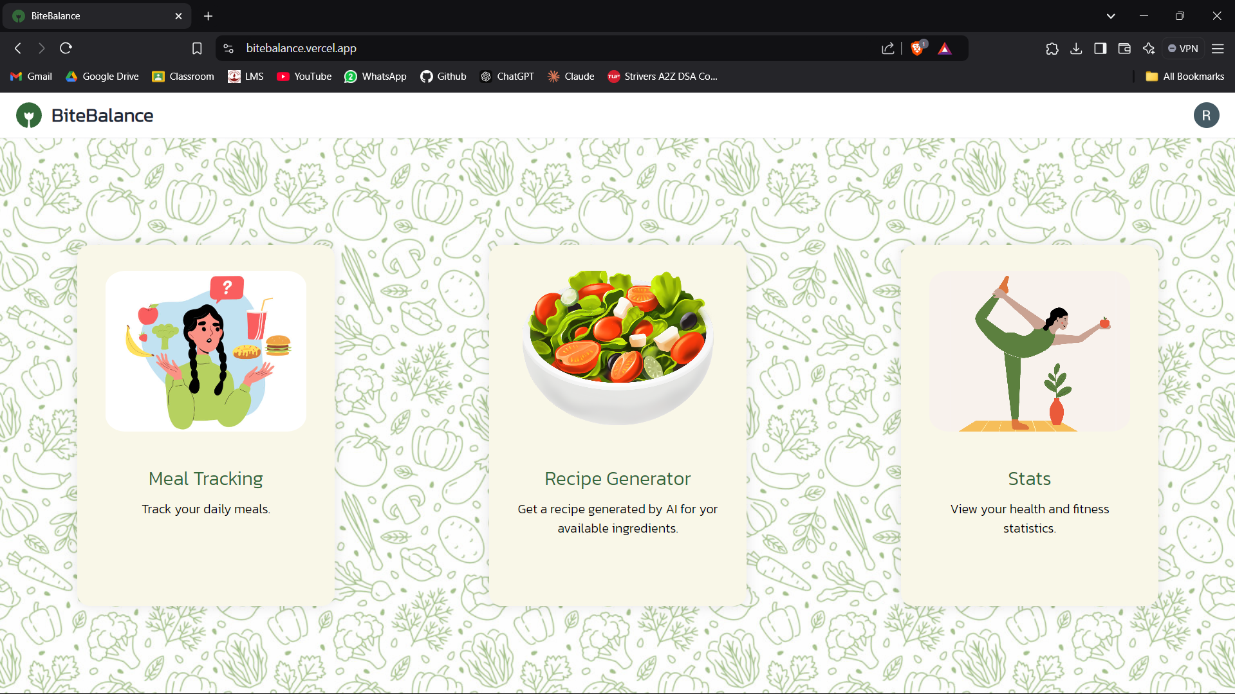

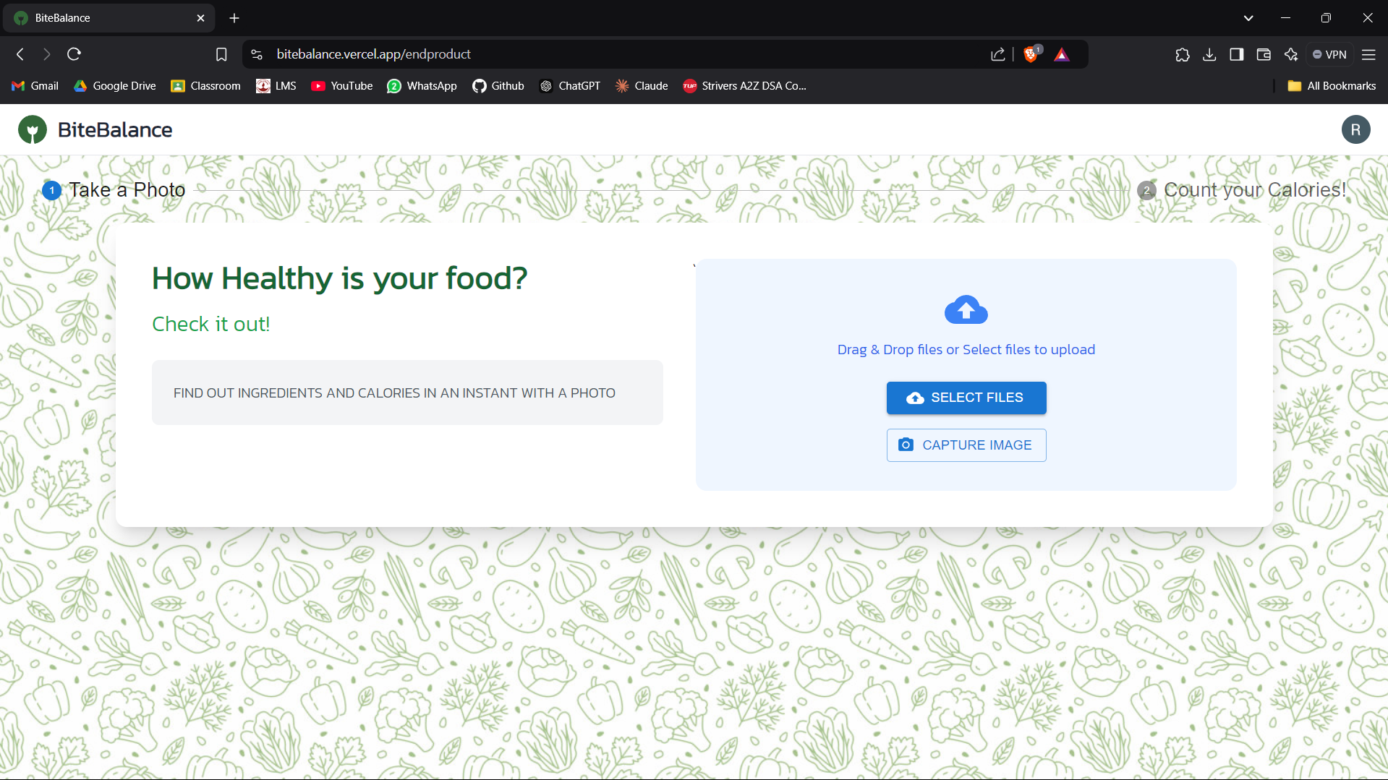

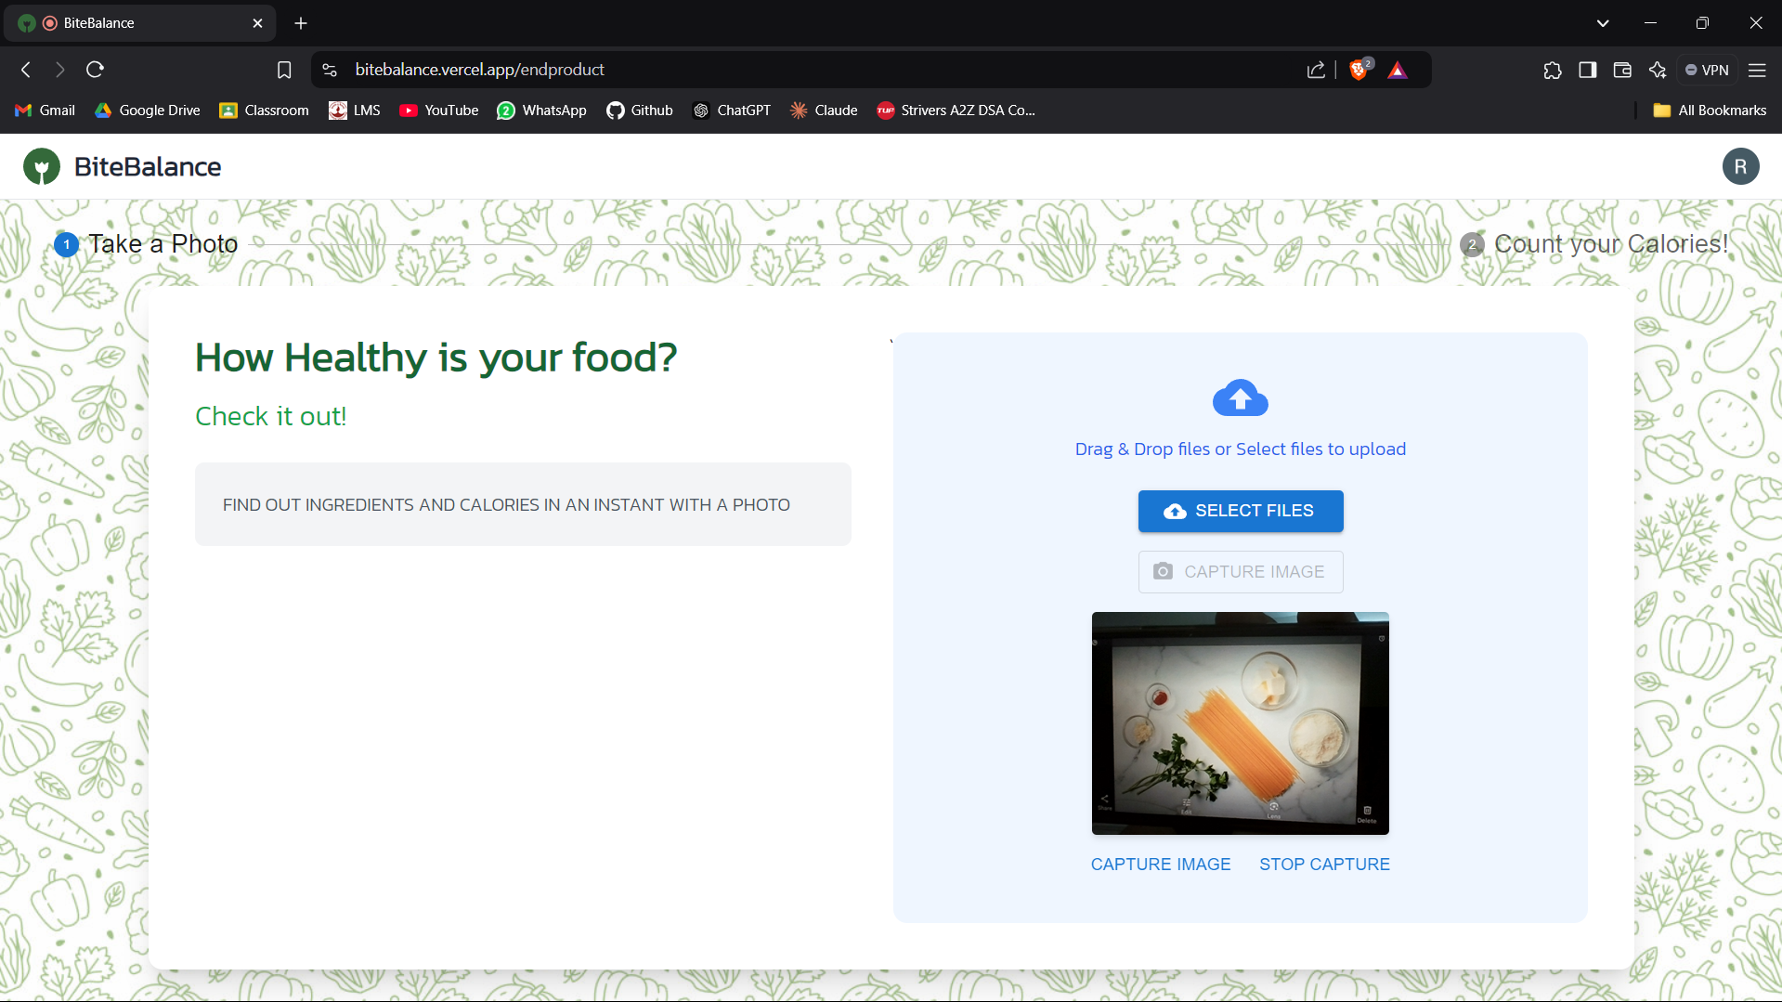

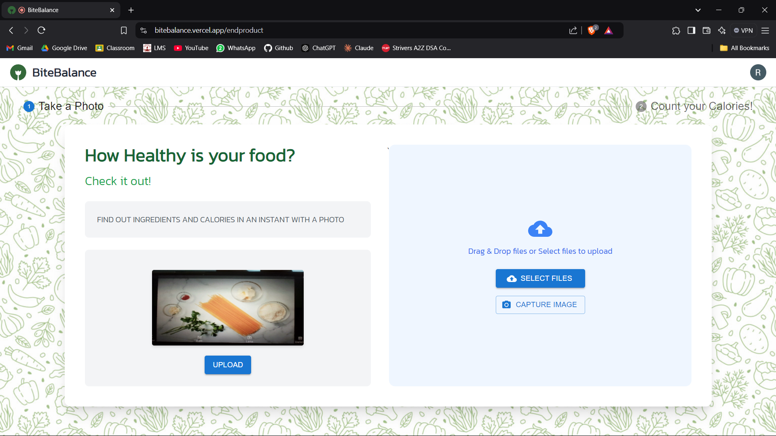

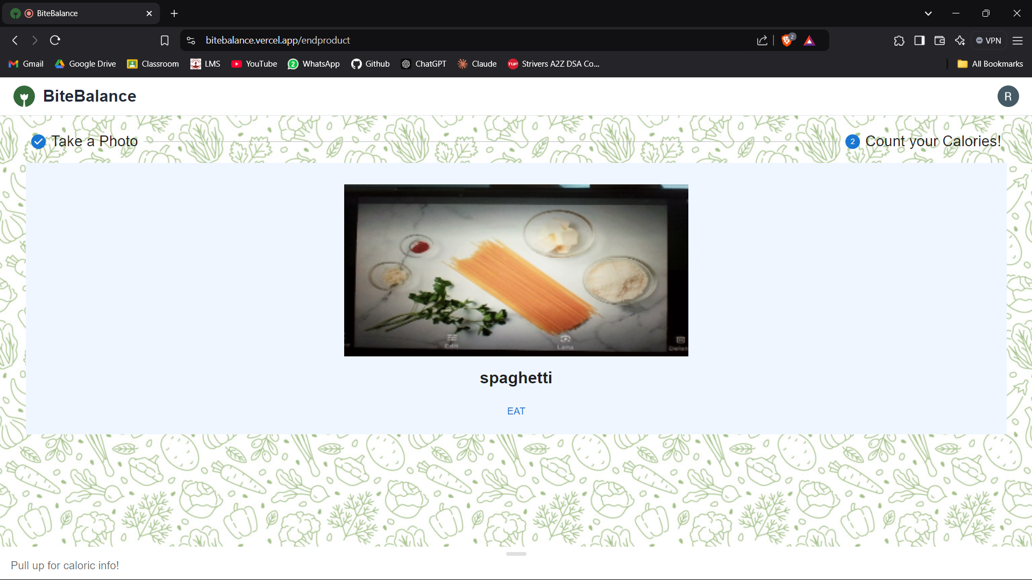

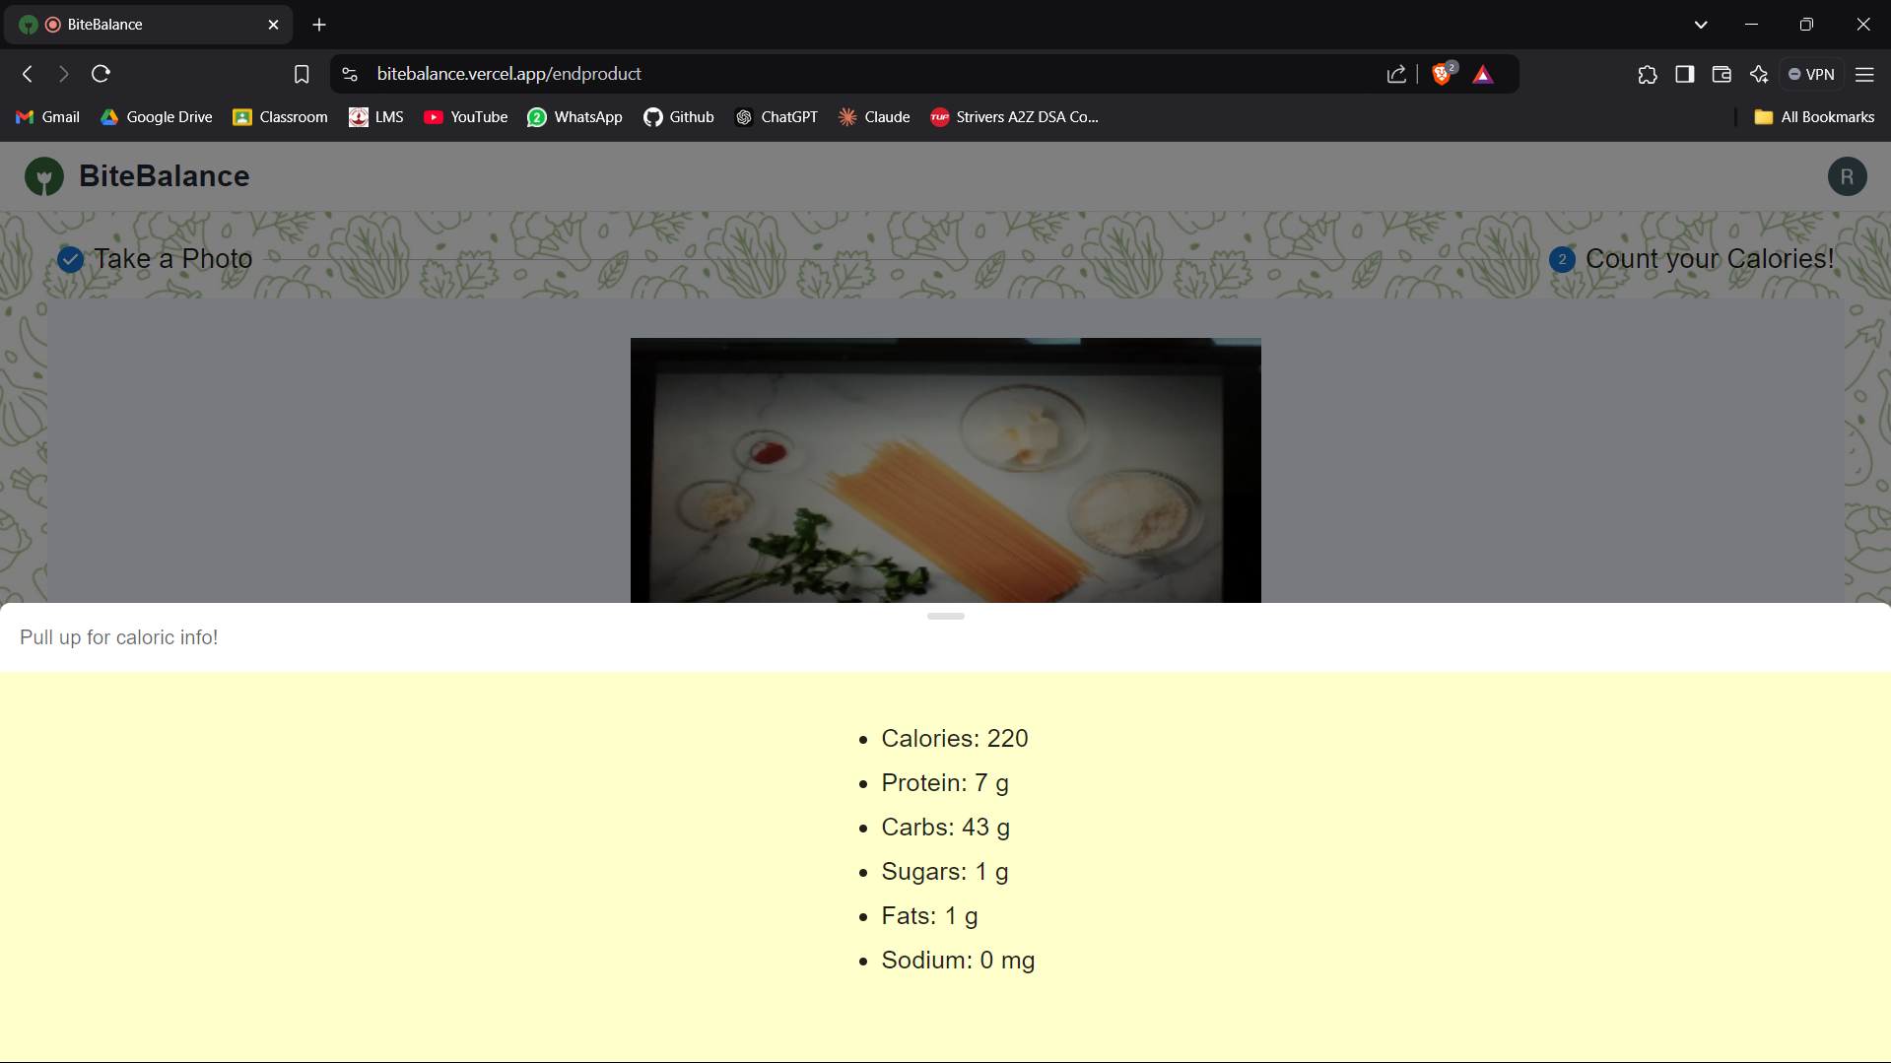

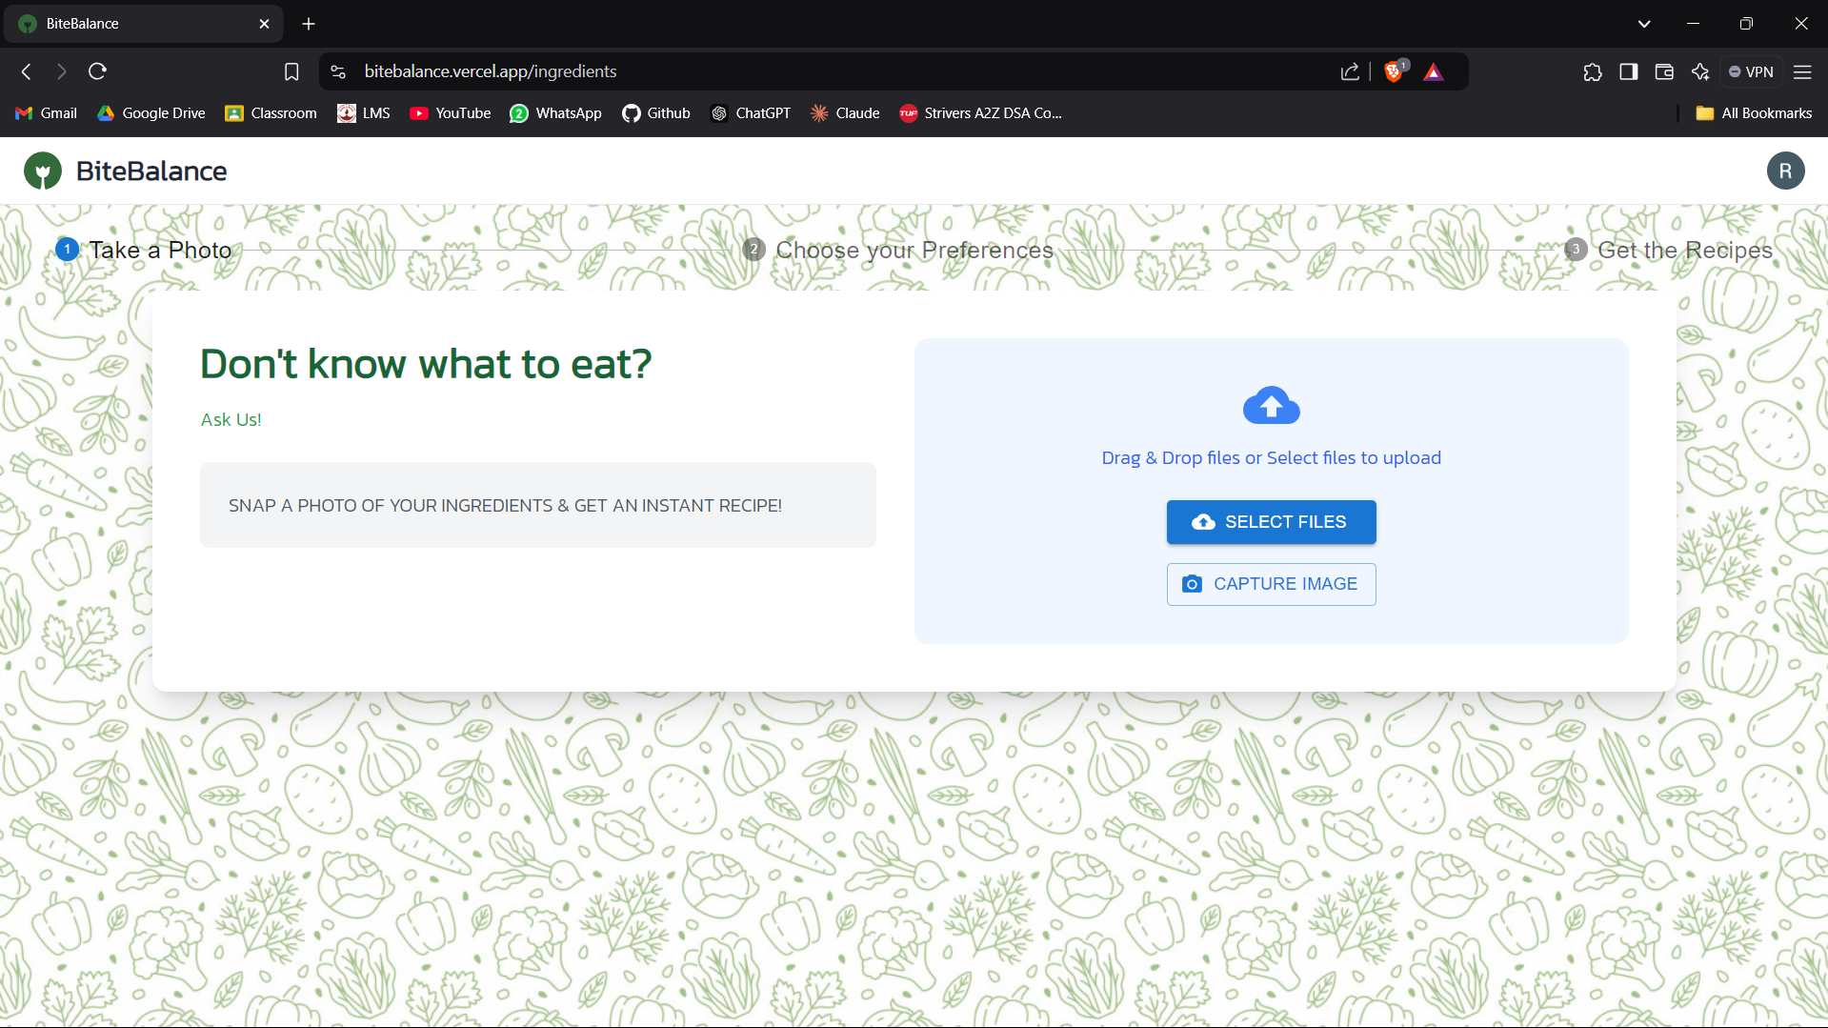

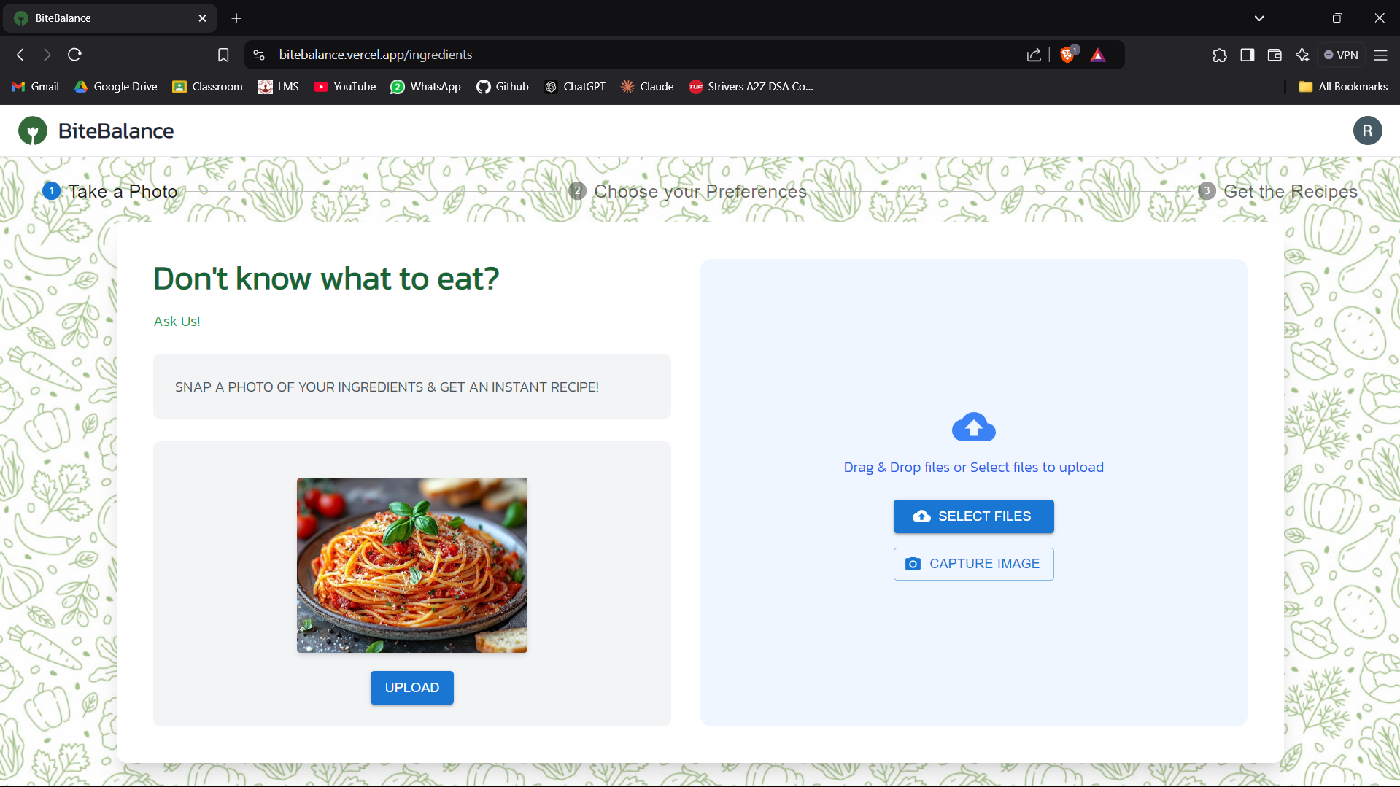

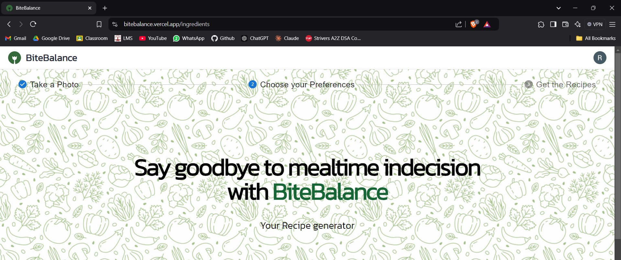

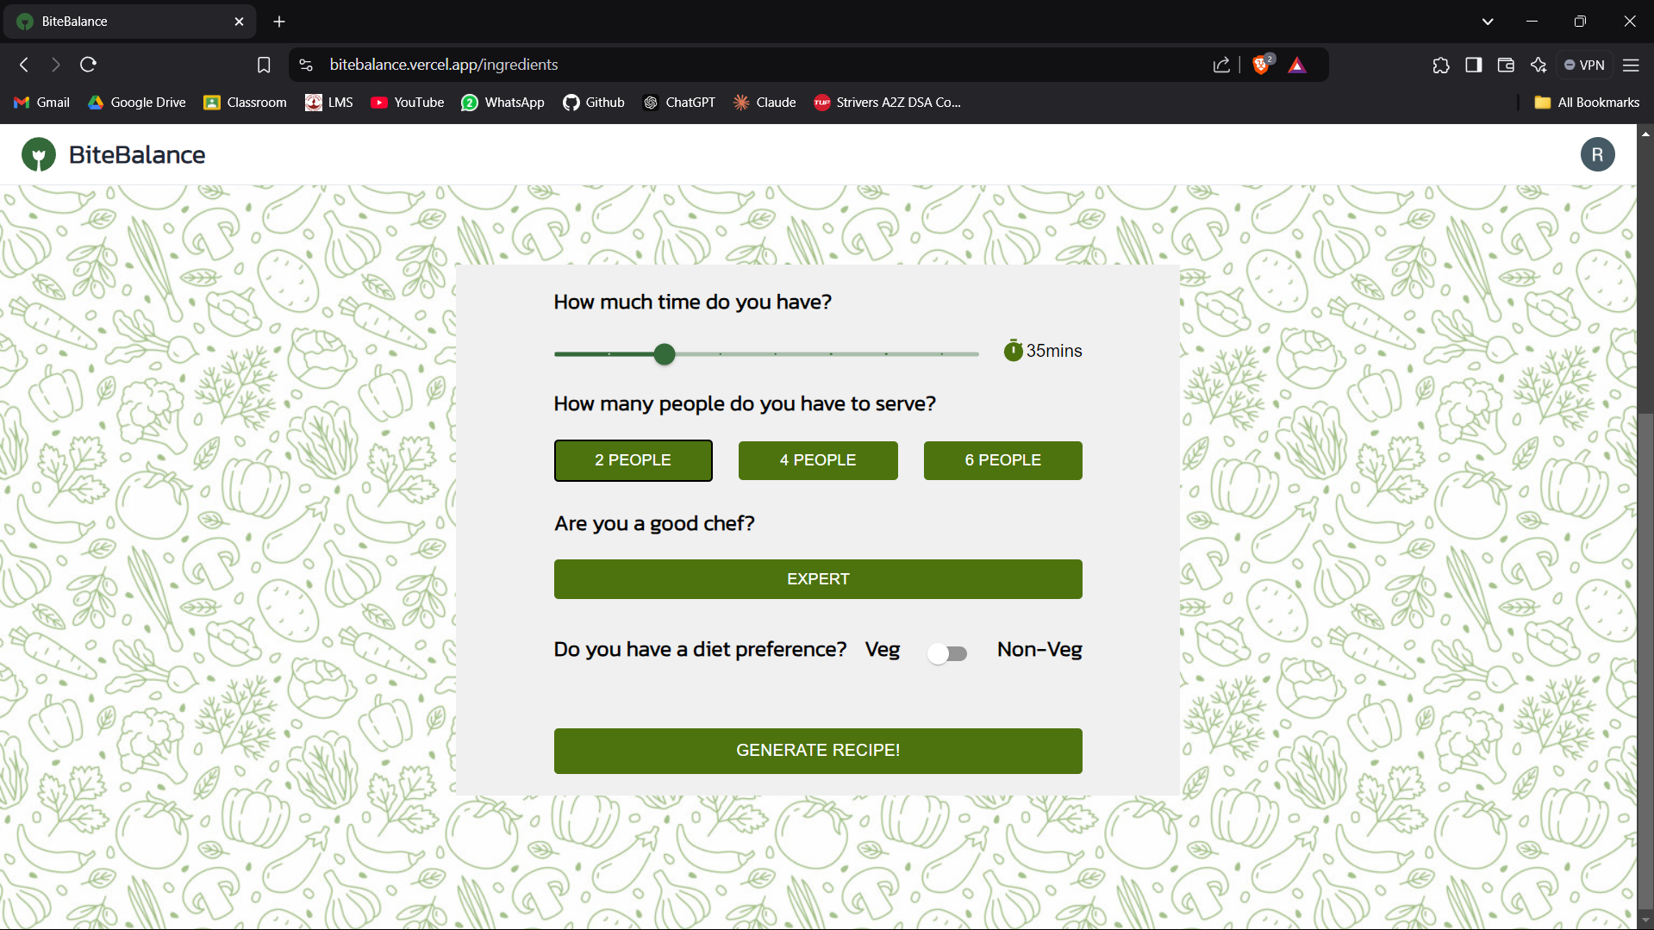

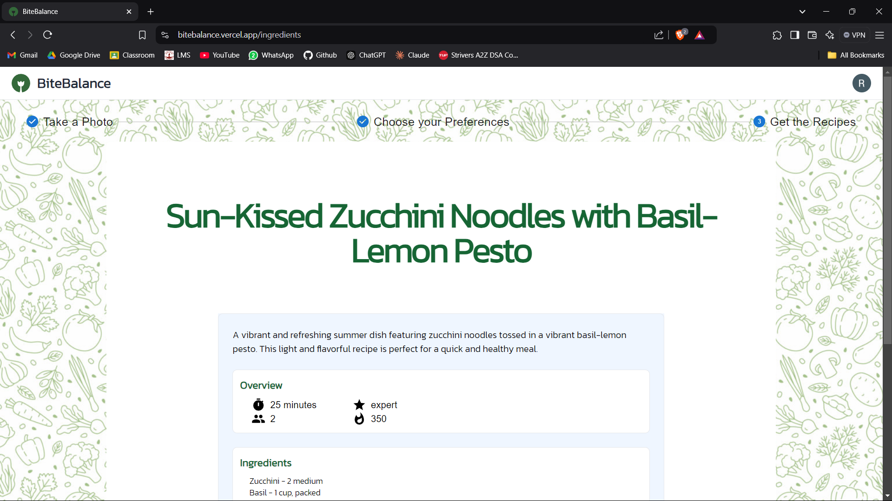

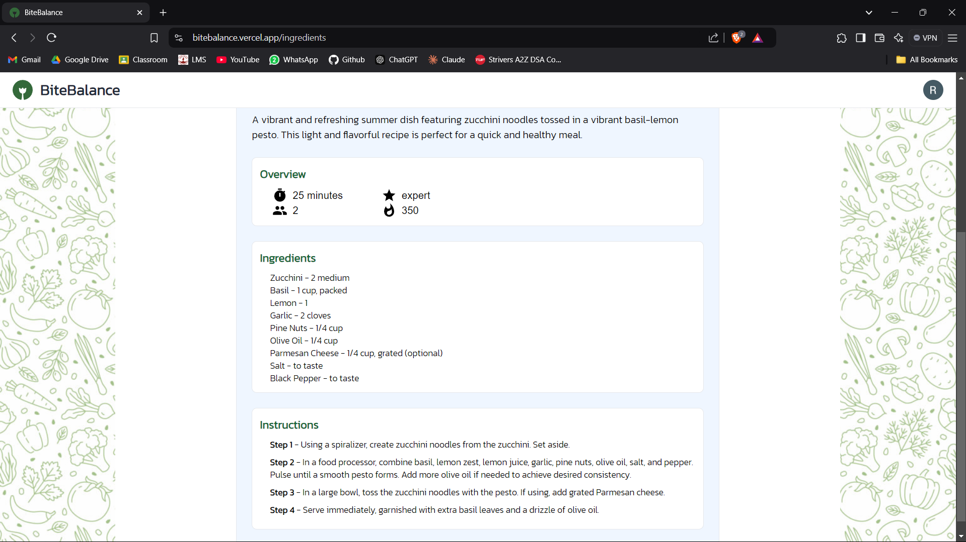

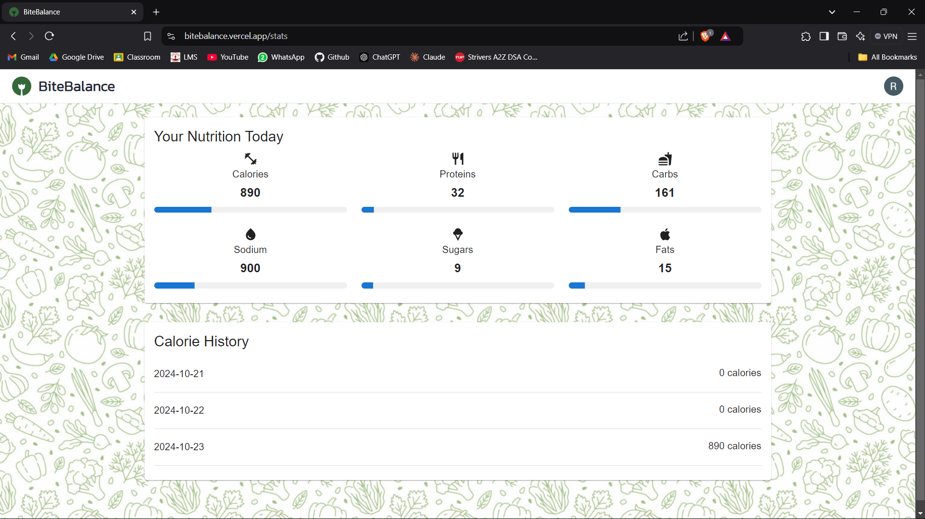

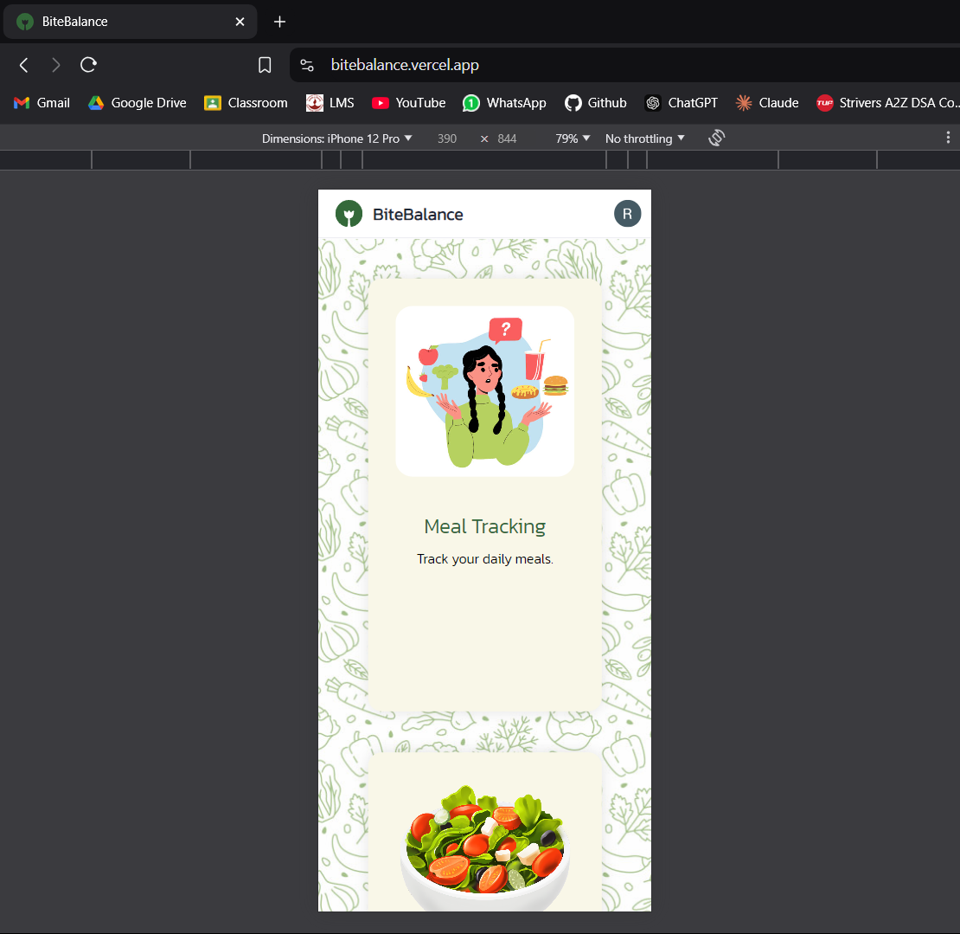

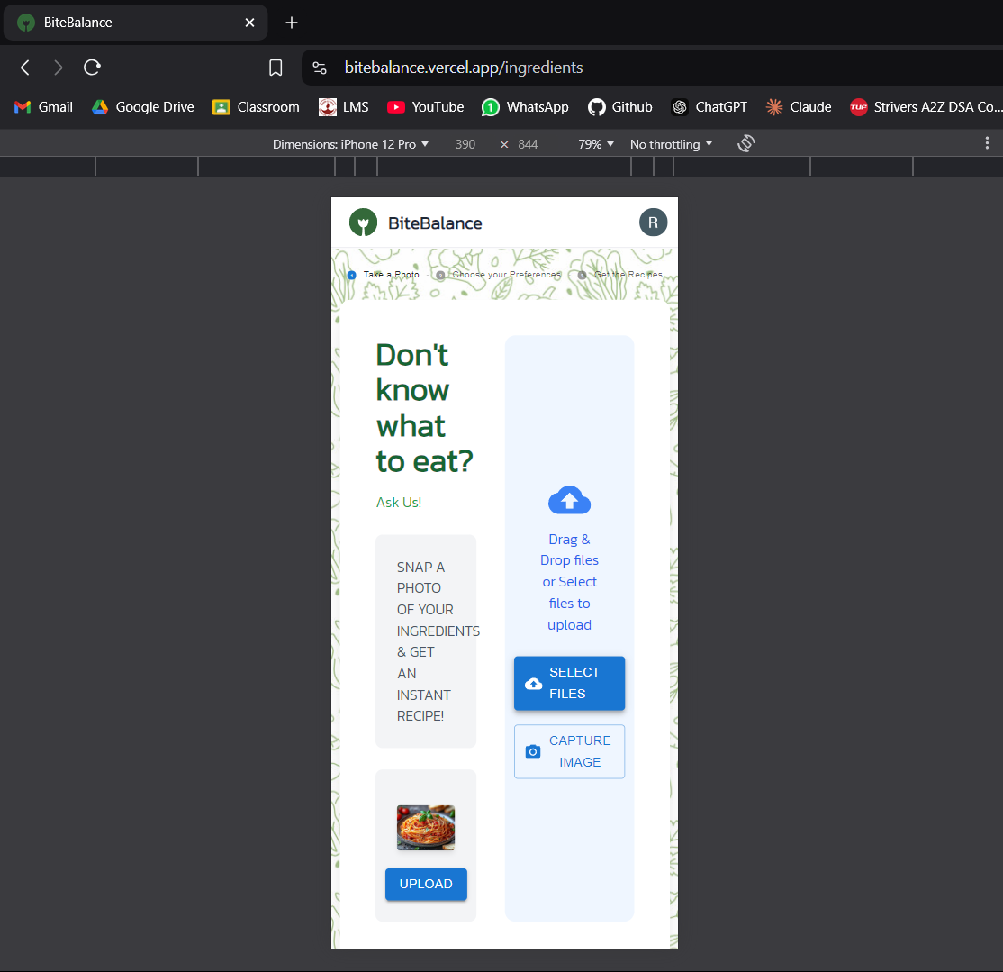

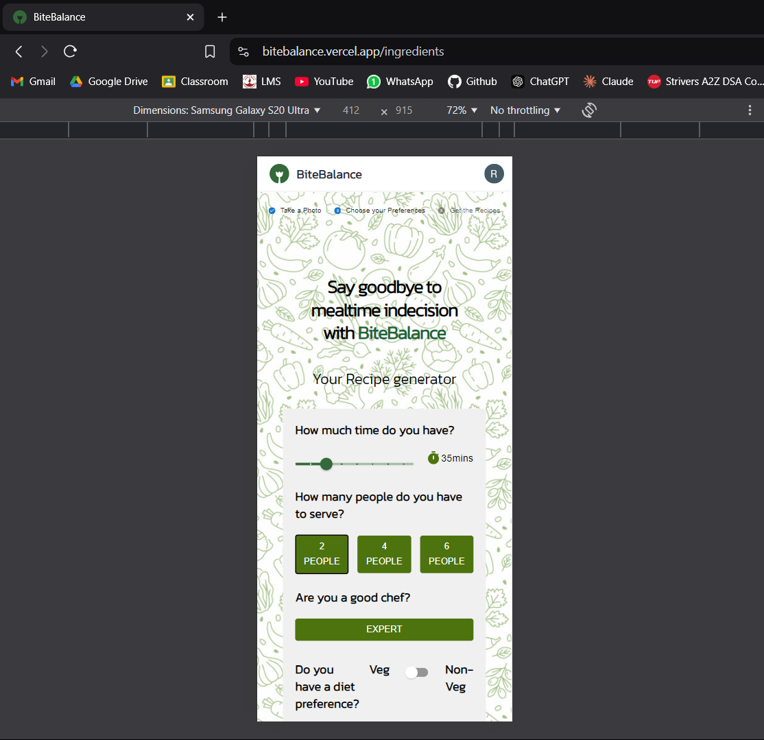

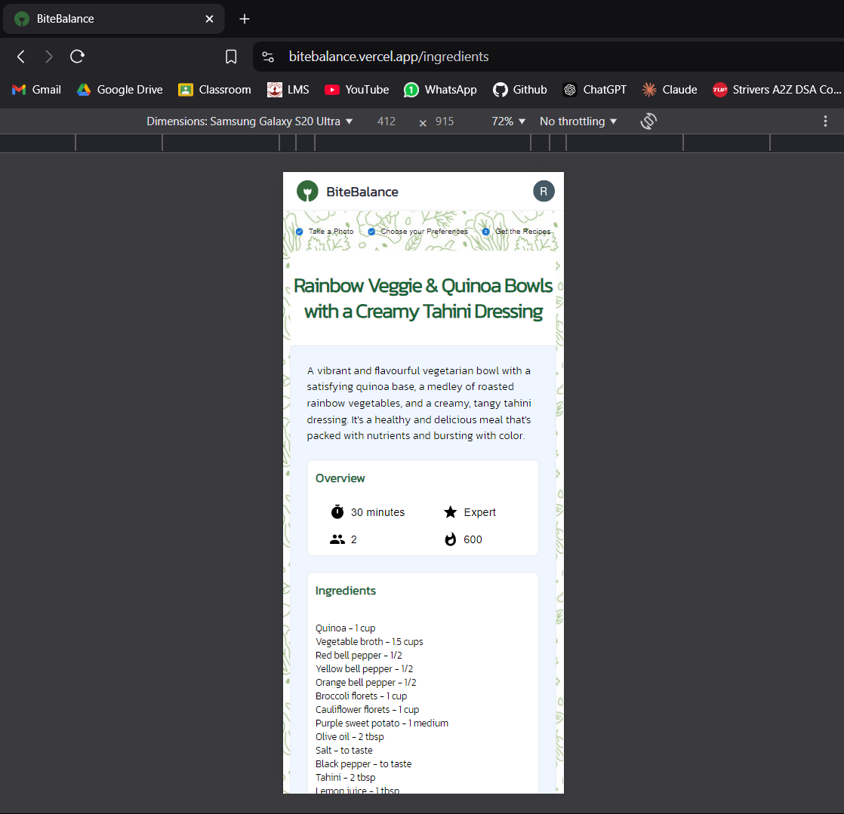

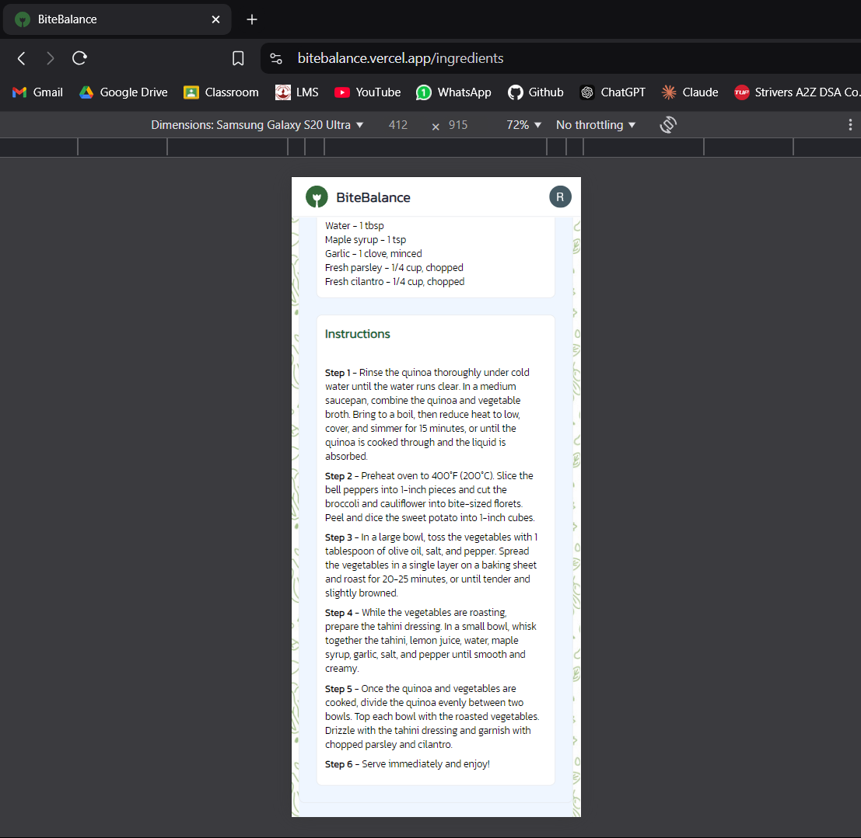

**Tech Stack Used:**

**Frontend:**

* **React.js:** For building a responsive and dynamic user interface.
* **Material UI (MUI):** Used for designing components with a modern look and feel, ensuring a smooth user experience across devices.
* **Firebase Authentication:** Ensures secure and simple user login and registration flows, integrated seamlessly into the frontend.

**Backend:**

* **Node.js and Express:** Handles API requests, data processing, and communication between the frontend and backend.
* **Google Gemini AI:** Powers the image-based meal recognition, ingredient identification, and recipe generation through its generative capabilities.

**Database:**

* **MongoDB Atlas:** A cloud-hosted NoSQL database that stores user data, such as calorie and macro information, with high scalability and easy configuration.

**Features implemented:**

* **Image-Based Meal Recognition**: Users can upload a picture of their meal, and the system identifies the ingredients using generative AI (Gemini).
* **Calorie & Macros Tracking**: Automatically tracks total calorie intake and breakdown of macros (proteins, fats, carbs) based on recognized ingredients and meals.
* **Recipe Generation**: Provides meal recommendations and generates creative, personalized recipes based on user-defined preferences and dietary restrictions.
* **Daily Nutrition Insights**: Displays comprehensive stats of the user’s calorie and macro intake for the day, with an option to view past data.

**Technical Issues Encountered and Solved:**

**Issue: MongoDB Connection Error:**

* Problem: Faced intermittent connectivity issues with MongoDB Atlas during initial setup.
* Solution: Configured proper connection settings by enabling useNewUrlParser and useUnifiedTopology options in Mongoose. Ensured that the MongoDB URI was correctly loaded from environment variables using dotenv.

**Issue: Image Upload and Processing:**

* Problem: Large images uploaded by users were causing performance issues when processing base64 data.
* Solution: Implemented request body size limits (limit: '50mb') in Express and ensured that base64 data was trimmed before processing. Added proper error handling to catch oversized uploads and notify users.

**Issue: Inconsistent AI Responses for Recipe Generation:**

* Problem: AI-generated recipe JSON had incorrect or extra formatting, making parsing difficult.
* Solution: Added additional string cleaning operations to strip out any extra markdown or unwanted characters before parsing the AI’s response as JSON.

**Issue: Managing Nutrition Data Across Days:**

* Problem: Users were unable to track their calorie intake correctly across different days.
* Solution: Adjusted the database query to reset date to midnight (using setHours(0, 0, 0, 0)) when updating or retrieving data, ensuring that daily records were managed independently.

**The future scope of the project is:**

* **Enhanced AI Capabilities**: Improve the accuracy and depth of meal recognition by training the AI on a wider variety of food datasets, ensuring it can recognize meals from diverse cuisines and handle complex food compositions with greater precision.
* **Integration with Wearable Devices**: Expand the platform by integrating with health and fitness wearables (e.g., Fitbit, Apple Watch) to track physical activity, calculate calorie expenditure, and provide users with a more comprehensive view of their health.
* **Advanced Personalization**: Introduce more personalized meal recommendations by leveraging user data such as food preferences, allergies, and health goals (e.g., weight loss, muscle gain), making the app a personalized nutrition coach.
* **Real-Time Nutritional Guidance**: Implement real-time nutritional advice and reminders based on user eating patterns and daily activity levels, helping users stay on track with their diet and health goals throughout the day.
* **Global Expansion**: Incorporate multi-language support and adapt meal recognition for different cultural diets, making the app accessible to a broader, global audience.
* **Food Barcode Scanning**: Add a barcode scanning feature to quickly input store-bought food items, retrieve nutritional information from packaged goods, and automatically log them into the user's daily tracking.
* **Community Features**: Introduce social and community elements, allowing users to share their meals, recipes, and nutritional progress with others, fostering a supportive environment for health-conscious individuals.
* **Integration with Meal Delivery Services**: Collaborate with meal delivery platforms to offer users the convenience of ordering recommended meals directly from the app based on their dietary needs and preferences.
* **Offline Mode**: Enable offline functionality where users can track their meals and access previously logged data even without an internet connection, syncing the data when they come back online.
* **AI-Driven Meal Plan Optimization**: Incorporate AI-driven meal plan optimization, which suggests weekly meal plans and shopping lists tailored to users’ nutritional goals, budget, and time constraints.

**Read Me File:**

[**BiteBalance**](https://bitebalance.vercel.app/)is a MERN stack web application designed to track your daily calorie and macro intake through photo recognition. Users can take photos of their meals to estimate calories and macronutrients, and also generate creative recipes based on ingredients and dietary preferences.

**Features**

* **Photo-based Calorie & Macro Recognition**: Upload a photo of your meal to recognize calories and macros (protein, carbs, fats, sugars, sodium) using Google Gemini AI.
* **Ingredient-based Recipe Generation**: Take a photo of your ingredients, enter dietary preferences, and generate recipes that meet your specified cooking time and difficulty.
* **Daily Nutrition Tracking**: Track calories and macros for each day, view consolidated stats over the past few days.
* **User Authentication**: Firebase authentication for user login and registration.

**Tech Stack**

**Frontend:**

* **React.js**: For building a responsive and dynamic user interface.
* **Material UI (MUI)**: Component library used for modern, responsive design.
* **Firebase Authentication**: Secure user login and registration.
* **Backend:**
* **Node.js & Express**: Handle API requests and data processing.
* **Google Gemini AI**: Powers the image-based meal recognition and recipe generation.
* **MongoDB Atlas**: Cloud-hosted NoSQL database for storing user data (calories, macros, etc.).

**Getting Started**

**Prerequisites**

Make sure you have the following installed:

* [Node.js](https://nodejs.org/)
* [MongoDB Atlas](https://www.mongodb.com/cloud/atlas)
* [Firebase](https://firebase.google.com/) (for authentication setup)
* Google Generative AI access for Gemini model API.

**Installation**

1. **Clone the repository:**

git clone <https://github.com/yourusername/bitebalance.git>

cd bitebalance

1. **Install dependencies:**

npm install

1. **Set up environment variables:**

Create a .env file in the root of the project with the following values:

* MONGO_URI=<your_mongodb_atlas_uri>
* API_KEY=<your_google_gemini_api_key>
* FIREBASE_API_KEY=<your_firebase_api_key>
* AUTH_DOMAIN=<your_firebase_auth_domain>
* PROJECT_ID=<your_firebase_project_id>
* STORAGE_BUCKET=<your_firebase_storage_bucket>
* MESSAGING_SENDER_ID=<your_firebase_messaging_sender_id>
* APP_ID=<your_firebase_app_id>

1. **Start the server:**

npm start

1. **Start the React app:**

cd client

npm start

**Usage**

* **Sign Up/Login**: Use Firebase authentication to register or sign in.
* **Upload a Meal Photo**: Use the upload feature to take a photo of your meal and get the estimated calorie and macro breakdown.
* **Generate a Recipe**: Take a photo of ingredients, specify dietary preferences, and get a custom recipe.
* **View Nutrition Stats**: See your daily calorie and macro consumption and track it over time.

**API Endpoints**

* POST /generate-ingredients: Upload a base64-encoded image to generate a list of ingredients.
* POST /generate-recipe: Generate a recipe based on dietary preferences and available ingredients.
* GET /calories/:userId: Retrieve user's calorie and macro data (optionally filtered by date).
* POST /calories/update: Update user’s calorie and macro consumption.